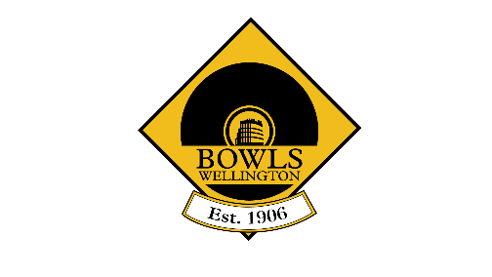
Diamond Buckles & Buttons 2024-2025

Buckles (men)  Plimmerton 2023-2024 Champion  Order of challenges:  - Victoria  - Massey Avenue  - Petone Central  - Hutt  - Silverstream  - Wainuiomata  Results  6 March Plimmerton vs Victoria, win by default to Plimmerton  13 March Plimmerton 23 Massey Avenue 15  Plimmerton win by default against Petone Central  Plimmerton 19 Hutt 10  Silverstream 19 Plimmerton 15  Silverstream 19 Wainuiomata 9  2024-25 Holders: Silverstream | Buttons (women)  Silverstream 2023-2024 Champion  Order of challenges  - Petone Central  - Massey Avenue  - Wainuiomata  - Plimmerton  - Hutt  Results  7 Feb 25: Silverstream 26 - Petone Central 10  21 Feb 25: Silverstream 19 – Massey Avenue 9  28 Feb 25: Silverstream Vs Wainuiomata. Win by default to Silverstream.  28 March Silverstream 20 Plimmerton 7  11 April Silverstream 25 Hutt 16  2024-25 Holders: Silverstream

