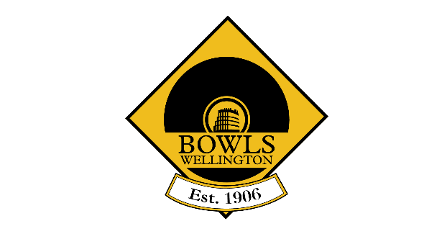
Bowls Wellington

Hutt Valley Bowl
Saturday 18th September 2021
Section 1 @ Upper Hutt
Section 2 @ Silverstream

Section 1: Section 2:
Naenae 2 Petone Central
Wainuiomata Naenae 1
Upper Hutt 1 Upper Hutt 2
Stoves Valley Massey Avenue

Conditions of Play
- All women bowlers eligible
2. To be played at Upper Hutt Bowling Club (section 1) and Silverstream Bowling Club (section 2) commencing at 9:30am.
3. Sides to consist of 1 x Four and 1 x 3-bowl Pair.
4. Each discipline will play three games.
5. Fours will play 16 ends and Pairs 18 ends.
6. Time Limit of 2 hours for all games.
7. Game points are awarded as 2 points per win and 1 point per draw.
8. The overall winner will be determined by the side’s combined total points from both disciplines.
9. If teams are equal on game points after the three rounds, the team with most wins, followed by most ends won will determine the winner. If still equal, the team with the best differential and finally lowest shots against will be used.
10. Where a club has 2 or more entries they will run independent of each other.

The draw will be distributed to clubs and online.

Tournament Manager: Dave Goodey
davidgoodey@hotmail.com 027 578 7285
At the end of each round, send a photo of the results to Dave Goodey’s cell phone :
(027 578 7285). If you cannot send a photo, please phone Dave with the result.

