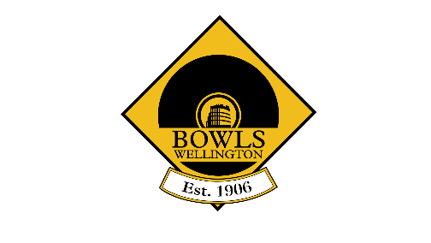
Diamond Buckles & Buttons 2025 - 2026

Buckles (men)  Silverstream 2024/25 Champion  Order of challenges:  - Wainuiomata  - Hutt  - Plimmerton  - Massey Avenue  Results | Buttons (women)  Silverstream 2024/25 Champion  Order of challenges  - Petone Central  - Plimmerton  - Massey Avenue  - Hutt  - Wainuiomata  Results

