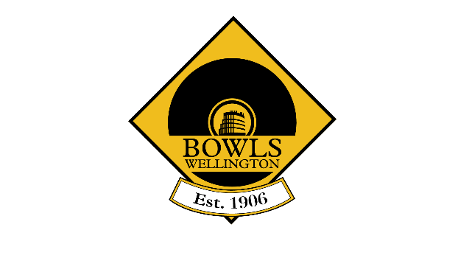
Bowls Wellington

Hutt Valley Cup
Saturday 18th September 2021
@ Massey Avenue

Conditions of Play

- All women bowlers eligible
- Play to commence at 9:30am at Massey Avenue Bowling Club.
3. Sides to consist of 1 x Four, 1 x 3-bowl Pair and 1 x 2-4-2 Pair.
4. Fours will play 16 ends, Pairs 18 ends and 2-4-2 Pairs 14 ends.
5. Time Limit of 2 hours per game. Each side to play three games.
6. Game points are awarded as 2 points per win and 1 point per draw.
7. The overall winner will be determined by the side’s combined total points from both disciplines.
8. If teams are equal on game points after the three rounds, the team with most wins, followed by most ends won will determine the winner. If still equal, the team with the best differential and finally lowest shots against will be used.

Draw will be distributed to clubs and online.
Results are to be provided to the Tournament Manager throughout the day.

Tournament Manager: Dave Goodey
davidgoodey@hotmail.com
027 578 7285

After each round send a photo of the result to Dave Goodey on 027 578 7285. If unable to send a photo, phone Dave with the result.

