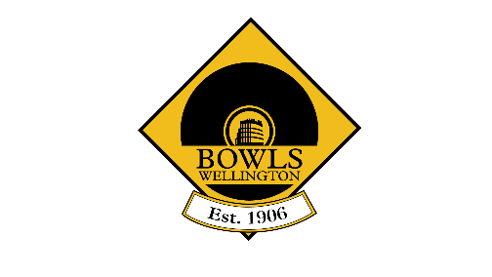
Diamond Buckles & Buttons 2023-2024

Buckles (men)  Hutt – 2022-2023 Champion  Order of challenges  - Naenae  - Silverstream  - Plimmerton  - Massey Avenue  - Island Bay  - Wainuiomata  - Petone Central  Results  3 Nov: Hutt 32 – Naenae 9  Hutt - Silverstream  Plimmerton - Hutt  19 Jan Plimmerton 21 Massey Avenue 19  12 Feb Plimmerton 23, Island Bay 12  19 Feb Plimmerton 25, Wainuiomata 15  26 Feb Plimmerton win by default vs Petone Central  2023-24 holder: Plimmerton | Buttons (women)  Plimmerton – 2022-2023 Champion  Order of challenges  - Massey Avenue  - Wainuiomata  - Hutt  - Petone Central  - Silverstream  Results  - Oct: Plimmerton 16 – Massey Ave 14  3 Nov: Plimmerton 17 Wainuiomata 11  24 Nov: Plimmerton 21 Hutt 1  8 Dec: Plimmerton 17 Petone Central 1  - March: Silverstream 24 Plimmerton 10  2023-24 holder: Silverstream

