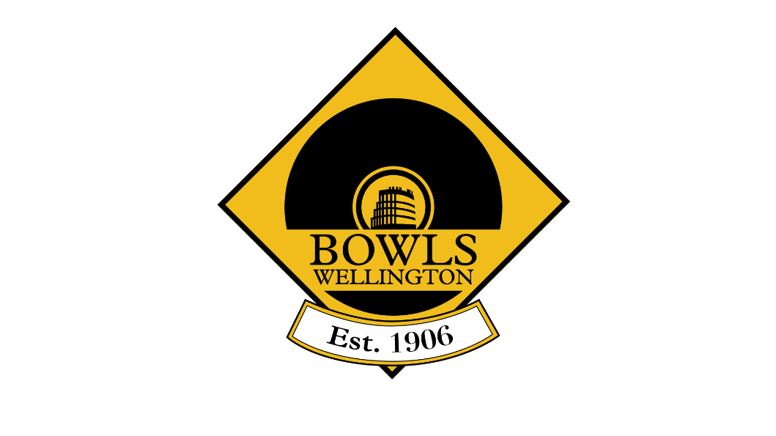

Annual Report
&
Financial Statements
2021-2022
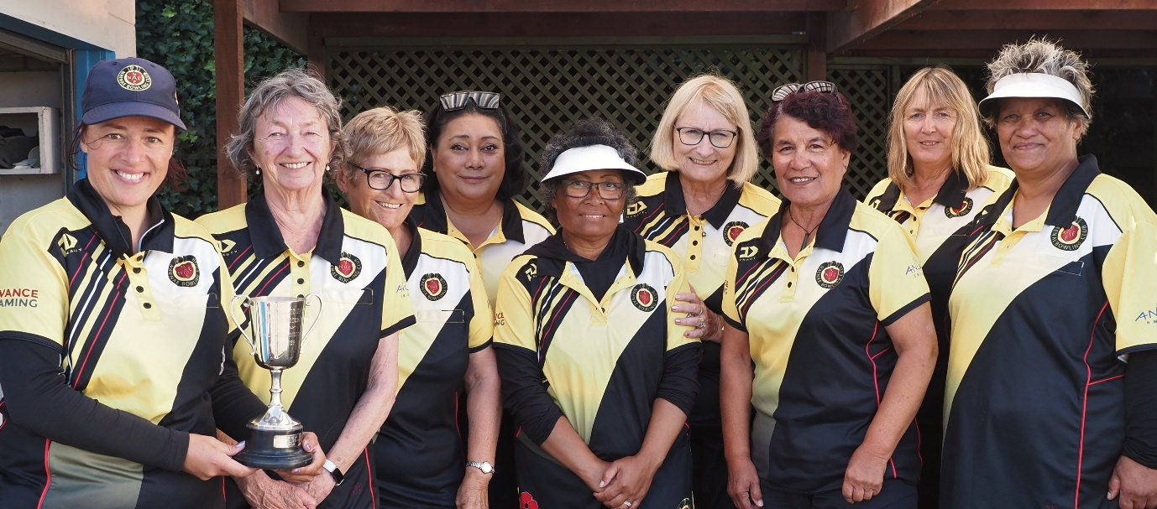

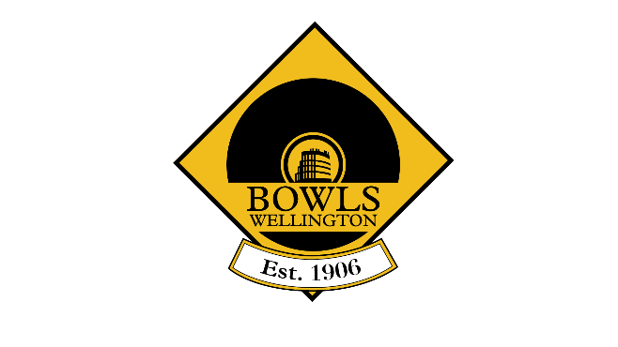
Annual General Meeting
Tuesday 23 August 2022 @ 8pm (after Delegate’s Meeting)
@ Pelorus Trust Sports House
Agenda
- Apologies

- Obituaries

- Confirmation of the Minutes of Annual General Meeting held August 24th, 2021

- Presentation of Annual Report (2021-2022)

- Presentation of Annual Financial Report (2021-2022)

- Election of President and Vice President
Nomination of President: Dayle Jackson (by Miramar)
Nomination of Vice President: Phil Todd (by Johnsonville)

- Appointment of Board Members
Rodney Leitch and Jason Puddick to be reappointed

Barry Jordan (Wilton) to replace Gerry Macgregor

- Bowls Wellington Affiliation fee
The Board recommends that the capitation fee be increased by 4.9% for the coming 2021-22 season, in keeping with the increase approved by Bowls New Zealand. This is based on membership fees as of Dec 31st, 2018 as per affiliation model.

Note the CPI at 31 March 2022 was 6.9%

- Appointment of Financial Reviewer

- General Business

- Fixing Date of next AGM – Tuesday, 22 August 2023
Bowls Wellington Inc.

Centre Board
Dayle Jackson (President)
Ralph Vulu (Vice President)
Susan Way (Chairperson)
Gerald Macgregor (Vice Chair)
Rodney Leitch, Sharman Buckle, Jason Puddick (Board)
Staff
Nigel Dixon (General Manager) to 29 April 2022
Blake Signal (General Manager) from 15 August 2022
Ross Gillett (Competitions and Administration Manager)
Brady Amer (Youth Engagement and Inclusivity Officer)

Tournament Manager
Gerry Macgregor

Greenkeeper’s Association
Howard Ivory (President)
Don McMurray (Secretary)

Umpire’s Association
Paul Hassall (President)
Dayle Jackson (Secretary)

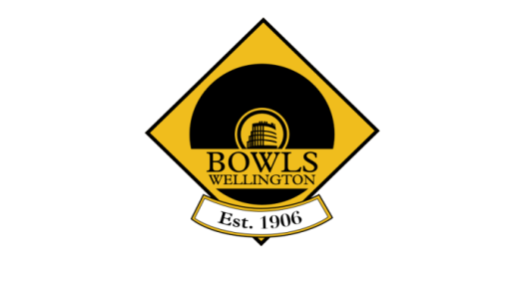
Bowls Wellington
Annual General Meeting Minutes
14 September 2021
At Hutt Bowling Club, 6 Myrtle Street, Lower Hutt

Present
Board: Susan Way (Chair), Dayle Jackson (President), Jason Puddick, and Sharman Buckle.
Clubs: Eastbourne, Hutt, Island Bay, Johnsonville, Karori, Khandallah, Miramar, Naenae, Petone Central, Plimmerton, Seatoun, Silverstream, Stokes Valley, Tawa, Tawa Services, Upper Hutt, Victoria, Wainuiomata, and Whitby.
In Attendance: Nigel Dixon (General Manager) and Angela Sheehan (Minutes).

The meeting commenced at 7.34 p.m.

1. Welcome and Apologies
The Chair welcomed everyone to the meeting.
Apologies were received from Gerry Macgregor (Board), Newtown, and Wilton.

2. Obituaries
The obituaries had been noted in the Delegates’ meeting preceding the Annual General Meeting, and a minute’s silence observed for Philippa McCullough, Dennis Bold, Kathleen Glen, and Noa Ringaio (all Miramar), Bruce Watt (Tawa Services), Allan ‘Squid’ Dudley (Petone Central), Loughie Prendergast (Past President Petone Central), Cindy Down (Plimmerton), Al Savelio (Whitby), Godfrey Moana (Titahi Bay), Russell Dean (Upper Hutt), Peter Reddaway (Eastbourne), and John Ogilvie (Hutt).

3. Confirmation of Minutes of 2020 Annual General Meeting
It was resolved that the minutes of the Annual General Meeting held on 25 August 2020 be confirmed as a true and correct record of the meeting subject to adding the list of clubs present at the meeting.
Plimmerton / Naenae
Action: General Manager

There were no matters arising.

4. Presentation of Annual Report (2020-2021)
The President spoke to her report. She said that 2020/2021 had been an outstanding year for Bowls Wellington. She highlighted the following issues:

- The Champion of Champion concept had been an outstanding success – well done clubs for supporting it.
- Junior years 1 to 3 players would continue to pay no entry fee to Open events.
- The Senior selectors had named 40 players (20 ladies and 20 men) to participate in winter training at Naenae.
- Bowls Wellington had supported the two clubs that won the Wellington Interclub (Naenae women and Stokes Valley men) to travel to the National Interclub Finals in Christchurch, both winning bronze medals.
- The secondary school programme had increased, and was getting even bigger, with several clubs hosting competitions between local schools. It was critical that these young players had a good experience because they will be the bowlers of the future.
- It was pleasing that 85 bowlers from Wellington had attended the Bowls New Zealand Nationals in Central Otago, with much success. Nicole Toomey had won the National Singles and Laurie Guy and Sarah Taukamo the National Mixed Pairs. Leigh Griffin was recognised for winning five national titles, and she received her New Zealand Gold Star. Twenty-three Wellington players had reached the last 16. Congratulations to all.
- Players selected to represent the North Island – in a year when no international bowls were played – made the selections very important for the future opportunities. Congratulations to Seamus Curtin, Finbar McGuigan, Ray Martin, Clare Hendra, Nicole Toomey, and Dale Rayner.
- The Stokes Valley Bowls3Five Vipers, in a televised competition, gained the national title. Congratulations to all players.
- There had been increased participation from all clubs in Bowls Wellington Open Centre events. With more variety and options, there was now something for all bowlers.
- The employment of Ross Gillett as Competitions and Tournaments Manager had allowed the General Manager to focus on governance, growth, new programmes, and funding. Thank you both for the excellent communications going out to clubs.
- Clubs are the backbone of the sport, and congratulations to all clubs on playing their part this season. Keep up the good work, and continue to grow.

The Board Chair said she was proud to be the Board Chair and be part of Bowls Wellington. She thanked her fellow Board Members - Dayle, Gerry, Rod, Sharman, and Jason – for their work. Thank you also to the General Manager and the Competitions and Tournaments Manager for their work, and clubs for their support. She said that the Board had adopted a Strategic Plan for the next 10 years, which the General Manager will send out.
Action: General Manager

The Board Chair acknowledged the following people from Wellington who had received national awards: Lance Pascoe (Player of the Year Male), Nicole Toomey (Emerging Player of the Year Female), Finbar McGuigan (Emerging Player of the Year Male), Dayle Jackson (Umpire of the Year), and John Carter (Life Member of Bowls New Zealand). The meeting expressed their congratulations with applause.

The General Manager highlighted the following issues from his report:
- Thank you to all clubs for dealing with the uncertainty that the COVID-19 pandemic had brought and for having another successful season, with increased participation in most competitions.
- Thank you to Board Members for their support and their selfless commitment to good outcomes for bowls.
- Thank you to Ross Gillett, Competitions and Tournaments Manager, for the massive contribution he had made to the work of Bowls Wellington. They were lucky to have someone of Ross’s calibre and work ethic.
- While bowls had been a sport in decline for 40 years, they were starting now to see increased participation numbers in most Centre tournaments. The way that people engaged in the sport today was different, so clubs needed to welcome and accept that.
- The Champion of Champion Finals weekend was proving to be a great concept, creating a fantastic atmosphere and showcasing the region through live streaming. Unfortunately, Bowls New Zealand was unable to stream the next event, so a high priority will be given to finding funding needed to pay for that.
- There was a renewed focus on youth. Bowls Wellington looked forward to continuing to work closely with schools and students to cultivate and foster an appreciation of and love for the sport, which will see them come back to clubs when the time is right.
- Bowls Wellington will continue to build on current initiatives and introduce new ones so as to keep the sport relevant in what was a saturated recreation market. Of particular note, there was the new Bowls3Five Premier Tournament, a modified Twilight Bowls3Five competition, and the launching of the Bowls Wellington Supporters’ Club.
5. Presentation of Annual Financial Report 2020-2021
The General Manager said that Shayne O’Hagan of Small Business Accounting had reviewed the Annual Financial Statements.

For the second consecutive year the Financial Report reported a surplus for the year of $30,735. An increase in income was due in part to increased participation and to not having to cancel many tournaments, and also to increased sponsorship and grants. However, Wellington City Council’s sinking lid policy on new licences for pokie machines was a call to arms for sports organisations because they relied heavily on funding from grants.

Expenses had increased due mainly to the employment of the Competitions and Tournaments Manager but, despite that, they had still managed to return a healthy surplus. Bowls Wellington will continue working to ensure future growth in the game of bowls.

It was resolved that the Annual Report and Financial Statements for 2020-21 be accepted.
Sharman Buckle / Island Bay

6. Election of President and Vice-President
Miramar had nominated Dayle Jackson as President of Bowls Wellington. No other nominations had been received. Therefore, Dayle was re-elected unopposed.

Naenae had nominated Ralph Vulu as Vice-President of Bowls Wellington. No other nominations had been received. Therefore, Ralph was elected unopposed.

7. Appointment of Board Members
On the recommendation of the Selection Panel, it was resolved that Susan Way (Naenae) and Sharman Buckle (Miramar) be re-elected to the Board of Bowls Wellington.

8. Bowls Wellington Affiliation Fee
The Board Chair said that, after consideration, the Board had recommended that the capitation fee be increased by the Consumer Price Index (CPI) (1.5%) for the coming season.

It was resolved unanimously that the capitation fee be increased by the CPI (1.5%) for the coming 2021-22 season, based on membership fees as at 31 December 2018, and as per the affiliation model.
Island Bay / Sharman Buckle

Craig Walker (Khandallah) suggested that, in future, before recommending an increase in the affiliation fee the Board should do a budget of realistic revenue and expenditure projections. It was noted that a budget would not be indicative of a CPI increase due to uncertainty around funding and that a CPI increase is to smooth out increased operating costs. The board wished to avoid increasing the affiliation fee by more than CPI. The General Manager thanked Craig for his feedback and welcomed his expertise.

In reply to a suggestion from Anton Ferrari (Naenae), the General Manager said he will check with Bowls New Zealand when the current Bowls New Zealand affiliation model expires.
Action: General Manager

9. Appointment of Financial Reviewer
It was resolved that the services of Shayne O’Hagan of Small Business Accounting be retained as Financial Reviewer.
Susan Way / Petone Central

10. Appointment of Board Selection Panel
It was agreed that the Board appoint the Delegates’ representative on the Board Selection Panel.

11. General Business

11.1 Thanks to Bowls Wellington
On behalf of her club, Cath Thomson (Plimmerton) thanked Bowls Wellington for sending the President to the club’s opening day. Clubs appreciated that kind of support.

12. 2022 Annual General Meeting Date
The 2022 Annual General Meeting will be held on Tuesday, 23 August.

The meeting concluded at 8.27 p.m.

Minutes confirmed as a true and correct record:

_______________________________________ _____________________________
Chair Date

_______________________________________ _____________________________
General Manager Date

President’s Report 2021-2022 Season
Over the last season Covid regulations did not cause many problems for the Bowls Wellington Programme. We appreciate and thank the clubs for their support in becoming Vaccinated Clubs
thus, all members were confident in continuing to play.
- We congratulate the Naenae ladies’ Interclub team on not only winning their Premier Championship but being named as the Team of The Year in the Hutt Valley Sports Awards.
- Naenae Women Contesting the NZ Interclub Finals in November 2022.
- The players who were selected as trialists for the Commonwealth Games: Clare Hendra, Nicole Toomey, Dale Rayner, Seamus Curtin, Finbar McGuigan, Raymond Martin, and Lance Pascoe.
- Sue Way being appointed as a Technical Official to the Commonwealth Games.
- Nicole Toomey selected in the New Zealand team for the Trans-Tasman test series and the Commonwealth Games.
- Clare Hendra and Lance Pascoe reserves for the NZ Bowls team for the Commonwealth Games.
- Seamus Curtin, Raymond Martin, Finbar McGuigan, Clare Hendra, Dale Rayner, Nicole Toomey selected in the North Island Team.
- Seamus Curtin Champion of National Pairs title.
- Clare Hendra runner up at National Singles & Pairs titles.
- 38 members of Bowls Wellington entered into National Singles & Pairs.
- The National Fours were cancelled due to difficulty with travel because of Covid restrictions.
- Bowls Wellington Men and Ladies Intercentre teams qualifying for the BNZ Finals in October
- The Wellington Representative teams had an excellent season in the regional competitions.
- Stokes Valley reaching the semi-finals of the National Club Bowls3Five.
- 16 Clubs whose members participated in Wellington Open events.
- 23 Clubs entered teams into Dynasty Sport Interclub.
- Sarah Taukamo and Seamus Curtin are Bowls Wellington Players of the Year.
- Clubs of the Year Johnsonville Women and Stokes Valley Men.
- Secondary School competition increased, and a representative team is traveling away in July.
- The introduction of the Rangatahi Secondary Programme run by Brady Amer has been very successful at many Secondary Schools and the Duke of Edinburgh Awards continues.
- 45 Fours teams entered into the Veterans competition. Over forty players received their first Veterans badge.
- Michael Johnson becoming New Zealand Umpires’ Committee Chairman.
- 15/24 Clubs won at least one title during the 2021-2022 Programme.

Many Clubs offered varied competitions to Wellington Bowlers throughout the weeks, well done. This gave you all the opportunity to raise funds, receive prize money and enjoy yourselves.
New initiatives were events like the WinterFours competition which was won by Hutt who were presented with the Thelma Chapman Turner Trophy. The competition has just begun again with 19 teams participating.
The FoxPlan Premier Bowls3Five was played over one day of a weekend and won by Naenae 2. The players enjoy the fast-paced games and a day filled with excitement. 19 teams from 14 clubs participated.
The Twilight Bowls3Five continued with a new format with an extra set to be played if a draw occurs after the two sets. This format was not as exciting as the one end shootout. Numbers continue to grow.
The Champion of Champions Finals weekend continued with enormous success. Some clubs were concerned about the April date as a few had to rush some finals. The live screening was again a superb link advertising our sport especially when local bowling personalities were engaged in the commentary. A celebration of our sport.
We congratulate Lisa White for her idea to organise an event to raise funds for the Foxton Beach
Bowling Club pavilion which had been burnt beyond repair by vandals. The Gala and Auction were fully supported by Bowls Wellington members and raised over $21,000. The Wellington Ladies Representative team had enjoyed playing at Foxton just a few weeks prior.

The Naenae Indoor facility is a magnificent arena for bowling and many more players enjoyed the games away from wind and rain. Thank you Naenae for your organisation and acceptance of many events. The opportunity for our bowlers to see top bowlers and international events being played is outstanding.

Thank you to the Umpires for officiating at all home events. It is a concern that the numbers are dwindling and in 2023 there will an opportunity for Clubs to encourage members, not necessarily players to become an umpire or measurer. Keith Johnson, Tom Murfitt, and Beverley Lindsay received their Bowls New Zealand Umpires 25 Year continuous service badge.

The 23 sponsors associated with Bowls Wellington provided support for our programmes, representative fixtures, and purchasing of equipment for the Secondary Schools programme. We are very appreciative of their support in many ways.

The Bowls Wellington Greenkeepers Association continue to oversee the club greens and give support. We are indebted to the Club greenkeepers for continuing to provide a high level of almost perfection for players.

We farewell and thank Gerry Macgregor who has been a Tournament Controller not for a couple of seasons but for decades of seasons. He was such an impact on all our lives along with his teammates Keith Johnson and John Harvey. Gerry your contributions for our Centre has been immense. Enjoy getting back your weekends and planning family time.

The Bowls Wellington Board have spent their year continuing their work to ensure the best possible outcomes for you all.

We are fortunate to have had a dynamic office staff who have worked diligently to set the details for our sport behind the scenes. Thank you, Nigel Dixon, Ross Gillett, and Brady Amer, and in recent weeks Sue Way, Chairman of the Board.

Clubs thank you for your efforts to ensure your communities have an active bowling club and your organisation is effective and continuous. You provide the facilities and the members who make it all work so successfully.
The Delegate meetings continue to be regular and a 98% attendance at each meeting ensured a two-way discussion between clubs and Bowls Wellington occurred.

Nigel Dixon, thank you, you were an incredible, and helpful General Manager. We appreciate the support you provided to us during your time. Thank you for your patience and advice. We wish you continued success on your road ahead.

Dayle Jackson - Bowls Wellington President.

Bowls Wellington

Board Chair Annual report 2021-2022

This year has had its challenges with the effects of Covid still being around and the extra work behind the scenes of our Bowls Wellington Staff. The roll-on effects of Interclub and Intercentre being rescheduled which will impact next season. The Board members had to make the decision to withdraw our Intercentre teams from travelling to Auckland. They considered the health and wellbeing of our players and coaches with the possible impacts being stuck in Auckland for an extended stay if anyone of them were to catch Covid and not be able to travel back to Wellington. Players were consulted and the decision was made to withdraw our teams. As a Board it was a very hard decision to make as so many players had put in a huge effort to make the team and wear our Bowls Wellington shirt. It is times like these that the strength of the Board to discuss, consider options and have robust debate has been outstanding. Thanks to Dayle Jackson, Ralph Vulu, Gerry Macgregor, Rod Leitch, Sharman Buckle and Jason Puddick for being such a great team.
Financially the centre is getting back on its feet but have managed to end this season in a similar position to last. The biggest outlay is for remuneration. A large part of remuneration is paid for by Grants. Nigel Dixon, our General Manager (till 29 April 2022) has put in a huge effort with applying for grant and gaining sponsorship. Nigel has spent 3 years with us and has introduced some new initiatives that we will build on with our new General Manger.
This season saw the introduction of an Engagement and Inclusivity Officer and employed Brady Amer part time to work with rangatahi outside our bowling community to give them the opportunity to participate in our sport. This position has been funded by Nuku Ora for a year and we hope to gain the funding for another year and continue sharing our sport with more rangatahi.
Without our crew at the office of Bowls Wellington could not offer the level of events we currently do. Ross Gillett, Competitions and Administration Manager, has done a sterling job increasing our levels of participation in most of our Centre events. Ross has also held the fort once Nigel resigned with keeping the office going and has been instrumental in getting the planning done for next season so our new General Manager can hit the ground running when he starts in August.
Our Tournaments have been professionally run over many years by Gerry Macgregor with help from Keith Johnson, John Harvey and others over a considerable period of time. Bowls Wellington will miss their expertise next season. Thanks very much from the players, clubs and Board of Bowls Wellington for the huge hours that have been put in to make sure all our events run effectively over many years. We wish you well in your retirement but still hope to see you watching some bowls and checking up on us from time to time.
Our Bowls Wellington Selectors, coaches and team managers have done a great job this season selecting and training our representative teams. It is always an honour to be selected in a team to represent the Wellington region be it senior, junior or the wider team. Both senior rep teams have made the national finals that have been deferred till November 2022.
Our Green keepers and umpires associations have played their part in the season we cannot run events without either Association. Both groups make sure that we can play at all levels. Many are volunteers who put in a huge amount of free time to make our sport happen. Thank you to you all.
Lastly our clubs and members who are the grass roots of our sport. Without you we wouldn’t have top level representative players, great greens and facilities, and awesome members who support our events and initiative’s. Together we all make up Bowls Wellington.

Thanks to everyone for your support in the 2021/22 season. We look forward to a new General Manager, a new season and new initiatives. Good Bowls.

Sue Way
Board Chair
Bowls Wellington

Bowls Wellington
General Managers Annual Report 2021 -22

The beginning of the season saw challenges with Covid and what it would mean to the scheduling of the season’s events. There was a great deal of uncertainty so the schedule had to be looked at and decisions had to be made that may affect the running of our centre program. We were fortunate to get all our scheduled events finished although there were effects of Covid as some players had to pull out, but the season went well in these strange times.
Numbers participating in our tournaments is back pe-covid 2017/18 numbers, the most pleasing has been both men’s and women’s open singles, prestige pairs, veterans and the Easter 242 being higher than 2017/18 season. A huge effort was put in by our Competitions Manger, Ross Gillett to increase playing numbers and a rallying of the troops to get us back on track. We are hoping that the increase in numbers will be again reflected next season. Thanks Ross
Bowls 3Five changed to a one-day premier event and a Monday night league. Naenae won the inaugural one-day premier event. We have, for the third year in a row, increased the number of teams entered. Thanks to Wilton for the use of your facilities and greens for the Premier event.
Champion of Champion weekend was again a huge success 17 of our 24 Clubs had teams play their way to the Semi-finals and were involved in the weekend. Thanks to Naenae for hosting the event.
The second year WinterFours got under way in May playing for the Thelma Chapman Turner trophy which she kindly donated before leaving the centre after many years of service as a player, umpire and latterly as a tournament manager. It was a shock to hear of her passing. We will remember her each year when the trophy is presented to the winning Club. Hutt won the inaugural Winter Fours.
Both men’s and women’s representative teams qualified for the National Finals of the Intercentre in a changed Intercentre event which had to be changed then postponed due Covid lock downs in Auckland. The national finals will be played in November 2022
Early in the season Bowls Wellington Applied to Tū Manawa Active Aotearoa Fund for the position of an Engagement and Inclusivity Officer. This funding was approved and we employed Brady Amer to work with young people to introduce them to the sport of bowls. Brady is actively working with students from 17 schools in the Wellington region. This work cannot be done without the use of clubs and their greens for sessions. A trip to Taranaki with the best Wellington secondary students to play against other centre secondary teams. We hope to gain funding again for 2022/23 season so we can keep Brady working with our young people.
The Supporters Club was launched as a new initiative which includes entry into all Bowls Wellington Open events. It seemed quite popular and will be doing it again next season.
Late April saw Nigel Dixon resign as General Manager to take up another role. The Board have appointed Blake Signal to take over the General Managers Role from August 2022.
Good luck to our Intercentre teams and the Naenae women’s Interclub going to Auckland in November to play for New Zealand Titles, we all wish you the best of bowling.
Thanks to Clubs, players, umpires, greenkeepers, commercial and funding partners, sponsors, friends, supporters and our community for the support over the season.
Lastly thanks to Gerry Macgregor for being an outstanding Tournament Manager over so many years. Your eye for detail and personal skills to make a tournament run successfully with the minimum of fuss has been appreciated by us all. We wish you well in your retirement. Thank you for the many hours you have put in over an extended period of time. See you around the green.

Sue Way
Acting General Manager April – May 2022

Centre Event Winners 2021-2022

Event Men Women
Open Singles Finbar McGuigan (Stokes Valley) Clare Hendra (Silverstream)
Open Pairs Sar Alefosio (s) June Wairau (s)
Robbie Yemm (Naenae) Lil George (Johnsonville)
Open Triples Lance Pascoe (s) Sarah Taukamo (s)
Seamus Curtin Helen King
Ryan Cappleman (Stokes Valley) Robyn Rintoul (Victoria)
Open Fours Gary Lawson (s) Lisa White (s)
Michael Carroll Rozanna Muriwai
Stephen Brien Anne Gately
John Brien (Stokes Valley) Kennie Critchlow (Naenae)
Easter Pairs Ross Thorn Sue Way
Robbie Bird (Naenae) Anne Gately (Naenae)
Development Pairs Mark Burgess Cath Thomson
Calum Finlayson (Victoria) Phillipa Christie (Plimmerton)
Mixed Pairs Mandy Boyd/Trevor Pascoe (Composite)
Prestige Pairs Sarah Taukamo (s)
Nina De Munnik (Victoria)
Veterans Trevor Ross (s) Val Hadfield (s)
Grant Wakefield Judy McAuley
Ken Brown Cath Thomson
Ross Gillett (Johnsonville) Phillipa Christie (Plimmerton)

Thank you to our Tournament Sponsors
TBI Health
Veterans
Kiwi Trophies and Engraving
Development 2-4-2 Pairs

Bowls Specialists
Mixed Pairs
Champion of Champion Winners 2021-2022

Event Men Women
COC Junior 1-5 Singles Hamish Ryan (Silverstream) Cath Thomson (Plimmerton)
COC Singles Stephen Ditfort (Petone Central) Birdie (Tui) Love (Stokes Valley)
COC Pairs Rob Ashton (s) Sarah Taukamo (s)
Grant Wakefield (Johnsonville) Mary-Ann Wilson (Victoria)
COC Triples Tony Hewitt (s) Nina De Munnik (s)
Mark Hewitt Sarah Taukamo
Martin Asprey Upper Hutt) Mary-Ann Wilson (Victoria)
COC Fours Stephen Ditfort (s) June Wairau (s)
Brendan Nye Lil George
Dave Goodey Dawn Neill
Dave Grant (Petone Central)) Merani Davis (Johnsonville)

Centre Gold Stars
10 Titles
Ross Thorn (Naenae)
5 Titles
Mandy Boyd (Stokes Valley)
Robbie Yemm (Naenae)
Robbie Bird (Naenae)
Kennie Critchlow (Naenae)
Grant Wakefield (Johnsonville)

Thank you to our Tournament Sponsors
BCITO
Easter Pairs
FoxPlan
Prestige Pairs
Ryman HealthCare
Champion of Champions

Bowls Wellington Annual Awards

Women’s Player of the Year Sarah Taukamo (Victoria)
Men’s Player of the Year Seamus Curtin (Stokes Valley)
Club of the Year Petone Central
Champion Club of the Year (Men) Stokes Valley
Champion Club of the Year (Women) Johnsonville
Greenkeeper of the Year Don McMurray
Official of the Year Kay Martin
Coach of the Year Not awarded
Administrators of the Year Gerry Macgregor & Keith Johnson

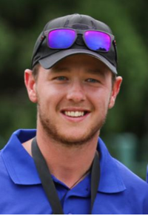
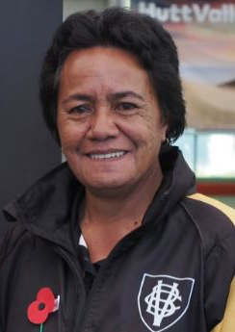

Sarah Taukamo (Victoria)
Women’s Player of the year
Seamus Curtin (Stokes Valley)
Men’s Player of the year

2021-2022 Club Competition Winners

Dynasty Sport Interclub Men Women
Premier Victoria Naenae
Division 1 Johnsonville Lyall Bay
Division 2 Petone Central Petone Central
Division 3 Tawa Services -
8s Division 1 Naenae -
8s Division 2 Naenae -
Quad Division Khandallah Johnsonville
Any Combo Quad Khandallah

Ryman Healthcare Pennants Men Women
Premier - Island Bay
Division 1 Island Bay Johnsonville
Division 2 Johnsonville Miramar
Division 3 Victoria Island Bay
Division 4 Lyall Bay -

Bowls3Five
Premier (Mixed) Naenae
Twilight Open Division (Any combo) Hutt
Twilight Junior Division (Any combo) Silverstream

WinterFours 2021 Any combo
Hutt

Thank you to our competition sponsors

2021-2022 Club Competition Winners

Dynasty Sport Interclub Men Women
Premier Victoria Naenae
Division 1 Johnsonville Lyall Bay
Division 2 Petone Central Petone Central
Division 3 Tawa Services -
8s Division 1 Naenae -
8s Division 2 Naenae -
Quad Division Khandallah Johnsonville
Any Combo Quad Khandallah

Ryman Healthcare Pennants Men Women
Premier - Island Bay
Division 1 Island Bay Johnsonville
Division 2 Johnsonville Miramar
Division 3 Victoria Island Bay
Division 4 Lyall Bay -

Bowls3Five Mixed
Premier Naenae
Twilight Open Division Hutt
Twilight Junior Division Silverstream

WinterFours 2021 Mixed
Hutt

Thank you to our competition sponsors

2021-2022 Wellington Representative Results
Manawatu
31 October 2021 @ Wellington
Result: Combined team – 1st

Tararua Quad
Wellington, Kapiti, Manawatu, Wairarapa
30 January 2022 @ Wellington
Result: Men – 1st
Women – 1st

Development Hexagonal
Wellington, Hawkes Bay, Kapiti, Manawatu, Taranaki, Wanganui (Development 1-8s)
12/13 February 2021 @ Wanganui
Result: No play – rained out

Octagonal
Wellington, Gisborne East Coast, Hawkes Bay, Kapiti, Manawatu, Taranaki, Wairarapa, Wanganui
11-13 February 2022 @ Manawatu
Result: Men – 2nd
Women – 1st

Masters
Wellington, Hutt Valley, Kapiti Coast, Manawatu, Wairarapa, Wanganui (Over 60s)
8/9 March 2021 @ Wanganui (men) & Wairarapa (women)
Result: Cancelled (Covid-19)

New Zealand Intercentre Zone
19 March 2022 @ Taranaki
Result: Men – 1st
Women – 1st

WKWM
Wellington, Kapiti, Manawatu, Wairarapa (Junior Women & Men 1-5s)
7 May 2022 @ Kapiti
Result: 1st

2021-2022 Wellington Representative Squads
Manawatu
(Gold) Men (Black) Men (Gold) Women (Black) Women
Seamus Curtin Finbar McGuigan Clare Hendra Sharon Ritchie
Ben King Raymond Martin Sarah Taukamo Alieta Vulu
Caleb Hope Robbie Bird Nicole Toomey Andy Gray
Grant Wakefield Stephen Ditfort Kennie Critchlow Robyn Rintoul
James Fairhall Sar Alefosio Anne Gately Cherie Brien

Tararua Quad
(Gold) Men (Black) Men (Gold) Women (Black) Women
Singles: Logan Amer Caleb Hope Lisa White Clare Hendra
Pairs: Robbie Bennett (s) Ray Martin (s) Sharon Ritchie (s) Dale Rayner (s)
John Brien Robbie Bird Andy Gray Kaaren Guilford
Fours: Laurie Guy (s) Ben King (s) June Wairau (s) Alieta Vulu (s)
Tim Toomey Grant Wakefield Anne Gately Kennie Critchlow
Stephen Brien Sar Alefosio Robyn Rintoul Pam Mulford
Mark Burgess Stephen Ditfort Kathy Cross Cherie Brien

Development Hexagonal Not Played-rained out

Men Women
Singles: Stephen Brien Cath Thomson
Pairs: Mark Burgess (s) Phillipa Christie (s)
Adam Ryan Sue Critchlow
Triples: John Brien (s) Gill Oliver (s)
Ian McLeod Fiona Alexander
Pet Johnson Lynette Campbell
Fours: Jim Maitland (s) Cherie Brien (s)
Gavin Bannatyne Kathy Cross
Nigel Musgrave Jenny Sellars
Brent Ahern Karen Ewart

Octagonal Men Women
Singles: Seamus Curtin Clare Hendra
Pairs: Ray Martin (s) Dale Rayner (s)
Stephen Ditfort Kaaren Guilford
Triples: Robbie Bennett (s) Lisa White (s)
Sar Alefosio Nicole Toomey
Grant Wakefield Sharon Ritchie
Fours: Ben King (s) Sarah Taukamo (s)
Finbar McGuigan Alieta Vulu
Caleb Hope Andy Gray
Robbie Bird Kennie Critchlow

Masters Not Played – Covid-19

Bowls NZ Intercentre Men Women
Singles: Seamus Curtin Lisa White
Pair: Raymond Martin (s) Dale Rayner (s)
Stephen Ditfort Kaaren Guilford
Fours: Ben King (s) Nicole Toomey
Finbar McGuigan Sarah Taukamo
Caleb Hope Sharon Ritchie
Robbie Bird Kennie Critchlow
Utility Player: Robbie Bennett

WKWM (1-5 Juniors) Men Women
Singles: Brent Ahern Cath Thomson
2-4-2 Pairs: Pet Johnson Phillipa Christie
Grayson May Sue Critchlow
Pairs: Kele Amato Kathy Cross
Ben Joseph Karen Ewart
Triples: Jason Anquetil Lynette Campbell
Hamish Ryan Natasha Maraku
Jayden Burns Simone Stewart

2021-22 Commercial Partners

2021-22 Funders

